## Front End Engineering-II

Project Report

Semester-IV (Batch-2022)

Material Price Tracker

**Supervised By: Submitted By:**

Mr. Saqlain Koser Ansari iBeta G27 2210992355(Shruti Bansal)

2210992401(Soumya Makkar)

2210992528(Vinay Kumar Mangal)

2210992532(Vinit Kumar)

**Department of Computer Science and Engineering**

## Chitkara University Institute of Engineering & Technology,

## Chitkara University, Punjab

**ABSTRACT:-**

The dynamic nature of today's market presents a significant challenge for businesses and consumers alike: volatile material prices. These unpredictable fluctuations can wreak havoc on budgets, impacting project profitability and household finances. Traditional methods of material cost management often rely on outdated data or intuition, leaving individuals and organizations vulnerable to unexpected market shifts.

This lack of reliable price tracking creates a critical obstacle to informed decision-making. Without a clear understanding of market trends, businesses and consumers struggle to strategically purchase materials. Companies risk overspending or under-stocking crucial supplies, while individuals grapple with price confusion and uncertainty when tackling home improvement projects or everyday shopping.

Our innovative Material Price Tracker empowers users to navigate this uncertainty with confidence. This comprehensive solution leverages the power of React, a JavaScript library, to provide real-time data and insightful visualizations on material price movements. Users can track historical trends, analyze market fluctuations, and predict future price changes. This transparency empowers strategic sourcing decisions, allowing businesses and consumers to optimize their budgets and maximize purchasing power.

.

The Material Price Tracker transforms the way users approach material purchases. It unlocks a world of transparency, empowering informed decisions and fostering a more efficient and cost-effective approach to navigating the ever-changing material price landscape.

###### **TABLE OF CONTENTS**

|  |  |  |
| --- | --- | --- |
| *Serial* no. | Section | Page No. |
| 1. | Introduction | *4-5* |
| 2. | Problem Statement | 6-7 |
| 3. | Technical Details | 8 |
| 4. | Key Features | 9 |
| 5. | Project Highlights | 10-19 |
| 6. | Results of the Project | 20-26 |
| 7. | Conclusions | 27 |
| 8. | References | 28 |

**INTRODUCTION:-**

In today's dynamic market, managing material costs can feel like a constant battle. Unpredictable price fluctuations can erode project budgets for businesses and leave individuals feeling frustrated when tackling home improvement projects. Traditional methods often rely on outdated information or intuition, leaving users vulnerable to market shifts.

This lack of reliable price tracking data creates a significant barrier to informed decision-making. Without a clear understanding of market trends, businesses struggle to strategically source materials. They risk overspending on in-demand materials or under-stocking crucial supplies, ultimately impacting project profitability. Individuals face similar challenges, unsure of whether they're getting the best deals or if prices will suddenly increase. Navigating material costs can feel like a guessing game.

The Material Price Tracker steps in to transform this uncertainty into a manageable equation. This innovative solution, built with the power of React, a JavaScript library, empowers users to gain control over material costs. The tracker provides real-time data and insightful visualizations on material price movements, allowing users to track historical trends, analyze market fluctuations, and even predict future changes.

With this level of transparency, the Material Price Tracker empowers informed decisions at all levels. Businesses can optimize their sourcing strategies, minimizing unnecessary expenses and maximizing purchasing power. Consumers can approach home improvement projects and everyday shopping with confidence, knowing they're getting the best possible value for their money. The Material Price Tracker unlocks a world of cost-effectiveness and informed decision-making, transforming the way users navigate the complexities of material pricing.

The Material Price Tracker goes beyond simply offering data. It leverages its insights to equip you with actionable tools. Imagine receiving alerts when a key material's price dips below a specific threshold, allowing you to capitalize on buying opportunities. Or, visualize future price forecasts to plan your budget and projects more effectively. The Material Price Tracker empowers you not just to understand material costs, but to strategically leverage them for your success.

**Features:**

**Reliable Data:** Access up-to-date pricing information on a vast range of materials, ensuring you always have the latest market insights at your fingertips.

**Easy-to-Use Interface:** The tracker boasts a user-friendly interface that caters to both technical and non-technical users. Navigate effortlessly, access data and visualizations quickly, and gain the insights you need to make informed purchasing decisions.

**Learning and Development:** Enhance your skills and qualifications with our online learning modules and certification programs.

These features, combined with the power of React, create a robust and efficient platform for managing material costs. The Material Price Tracker goes beyond just presenting data; it empowers you to analyze, predict, and make strategic decisions that optimize your bottom line.

By leveraging our Material price tracker you can help us empower the Future of Material Price Tracking.

**PROBLEM STATEMENT:-**

Imagine a world where project budgets evaporate overnight, home improvement dreams get put on hold, and shopping feels like a gamble. This isn't some dystopian future, but the harsh reality of navigating today's volatile material costs. Prices fluctuate wildly, leaving businesses and consumers alike clinging to their wallets and white-knuckling the price rollercoaster.

**Businesses** are stuck in a constant battle. Without reliable data on historical trends and future price movements, their sourcing strategies are akin to throwing darts blindfolded. They risk **overspending** on essential materials when prices spike, or **under-stocking** crucial supplies, jeopardizing project deadlines and profitability. Traditional methods of price tracking often rely on outdated information or gut instinct, leaving them vulnerable to sudden market shifts. This uncertainty creates a domino effect, impacting project budgets, employee morale, and ultimately, the company's bottom line.

**Consumers** face a similar uphill climb. Home improvement dreams turn into nightmares when the cost of lumber suddenly outpaces their budget. Everyday shopping becomes a guessing game – is this the best price, or will it plummet next week? The lack of transparency into price trends and historical data creates a breeding ground for frustration and missed opportunities. Consumers are forced to make **impulse purchases** for fear of missing out on deals, or delay projects indefinitely, unsure of when prices will stabilize.

The current approach to material cost management resembles a chaotic carnival ride: **unpredictable, time-consuming, and ultimately, a recipe for financial disaster.** There's a better way. We need a solution that empowers informed decisions, eliminates the guesswork, and puts the control back in the hands of businesses and consumers.

.

**SOLUTION:-**

In today's dynamic market, managing material costs can feel like a constant struggle. Unpredictable price fluctuations wreak havoc on project budgets and household finances. Businesses grapple with outdated data or gut instinct, leaving them vulnerable to sudden market shifts. This uncertainty leads to overspending on in-demand materials or under-stocking crucial supplies, ultimately impacting project profitability.

Consumers face similar challenges. Without transparency into price trends, tackling home improvement projects or everyday shopping becomes a guessing game. Will prices stay the same, or will they suddenly increase? This lack of knowledge leads to frustration and missed opportunities. Consumers might impulse buy for fear of missing out on deals, or delay projects indefinitely, unsure of future price stability.

The Material Price Tracker seeks to revolutionize this chaotic landscape. Built with the power of React, this innovative platform empowers users with the tools they need to make informed decisions and optimize purchasing power. Imagine a world where real-time data on a vast range of materials is readily available, ensuring accurate and up-to-date market insights. Businesses and consumers can analyze historical trends to identify patterns and anticipate potential fluctuations. Predictive analytics allow for forecasting future price movements, enabling better planning of budgets and projects. Additionally, customizable alerts keep users informed of critical market changes, allowing them to capitalize on buying opportunities

.

The Material Price Tracker goes beyond just data presentation. It empowers users to analyze, predict, and act. With intuitive charts and graphs, users can visualize data and understand the market landscape, comparing prices across different materials. The user-friendly interface caters to both technical and non-technical users, eliminating the need for time-consuming manual research. By stepping off the unpredictable price rollercoaster and embracing the Material Price Tracker, businesses and consumers can enter a new era of informed decision-making, cost optimization, and financial stability.

.

**PROPOSED DESIGN:**

Create a visually engaging and user-friendly online environment for Users with a simple yet calming color palette featuring soothing blues, black, and warm tones. Select readable and friendly fonts to strike a balance between aesthetics and legibility, ensuring a welcoming user experience.

**TECHNICAL DETAILS:**

**1.HTML:** Semantic Structure: Use HTML5 semantic elements for a clean and structured document outline. Accessibility: Ensure the website is accessible by using proper HTML tags and attributes. Responsive Design: Implement responsive HTML for a fluid layout across devices.

**2. CSS:** Responsive Styling: Apply responsive CSS styles using media queries for different screen sizes. Animation and Transitions: Incorporate subtle animations and transitions to enhance user experience.CSS Grid or Flexbox: Utilize CSS Grid or Flexbox for a flexible and grid-based layout.

**3. JavaScript (JS):** Dynamic Content Loading: Use JS to dynamically load content, especially for multimedia elements like images and videos. Form Validation: Implement client-side form validation for an improved user experience. Event Handling: Utilize JS for handling user interactions, such as clicks on the adoption button and form submissions.

**4. React:** React is a JavaScript based UI development library. Although react is a library rather than a language, it is widely used in web development. The library first appeared in May 2013 and now one of the most used frontend libraries for web development. It Is used for easy creating of dynamic application make it easy because it requires less coding and more functionality.

**KEY FEATURES**

**1. Visual Appeal**:

- Vibrant design, soothing colors, and heartwarming multimedia create an emotionally engaging environment.

**2. Intuitive Navigation**

- User-friendly interface with easy navigation for seamless exploration of key sections.

**3. Effortless Searching:**

- Prominent "SEARCH" button and simplified forms for a straightforward for price tracking.

**4. Multimedia Storytelling:**

- Dedicated photos and videos for making the viewer’s experience better.

**5. Responsive Design:**

- Ensures a smooth experience across devices, allowing users to engage from desktops to smartphones.

**6.Reviews from Business professionals:**

- Tells about reviews of different business professionals for further guidance.

**7. Dynamic Content Loading:**

- JavaScript-driven dynamic content loading for a smooth and interactive user experience.

**PROJECT HIGHLIGHTS:-**

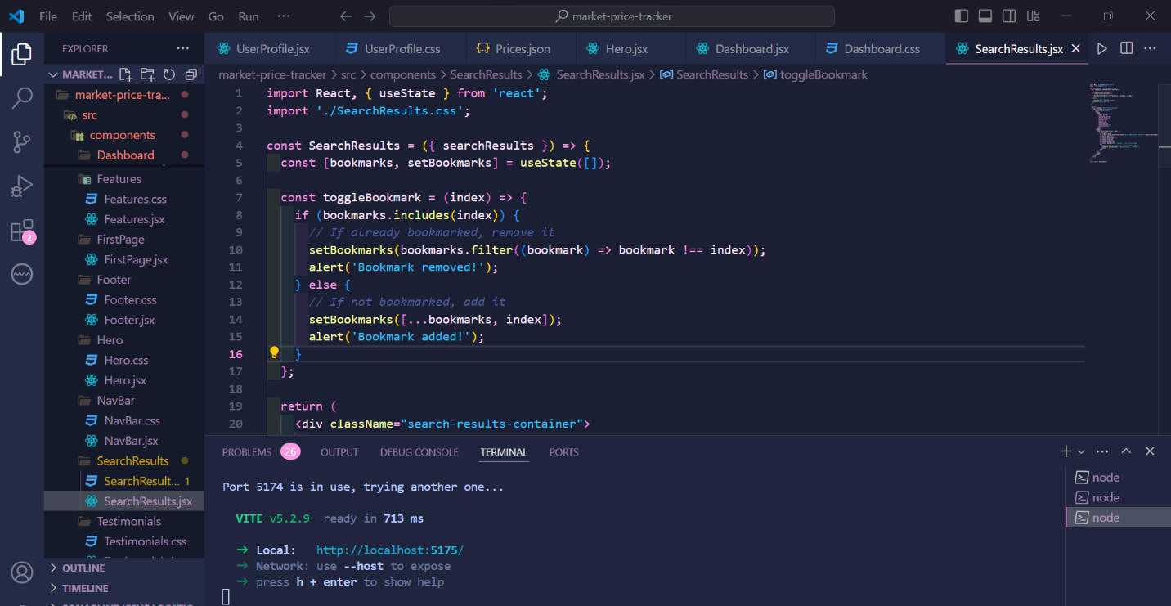

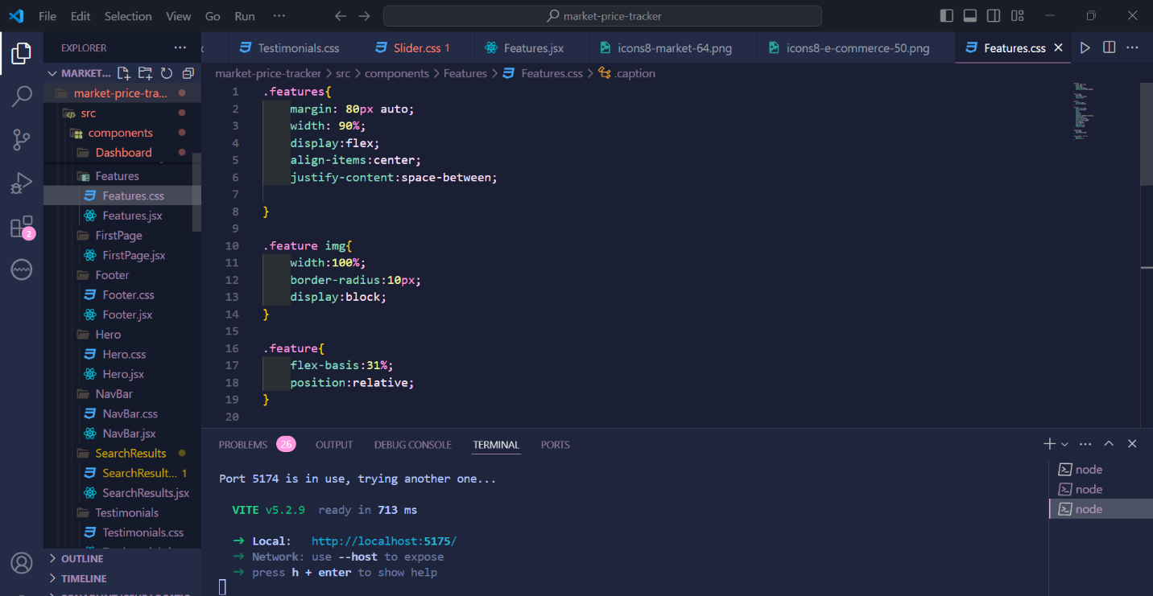

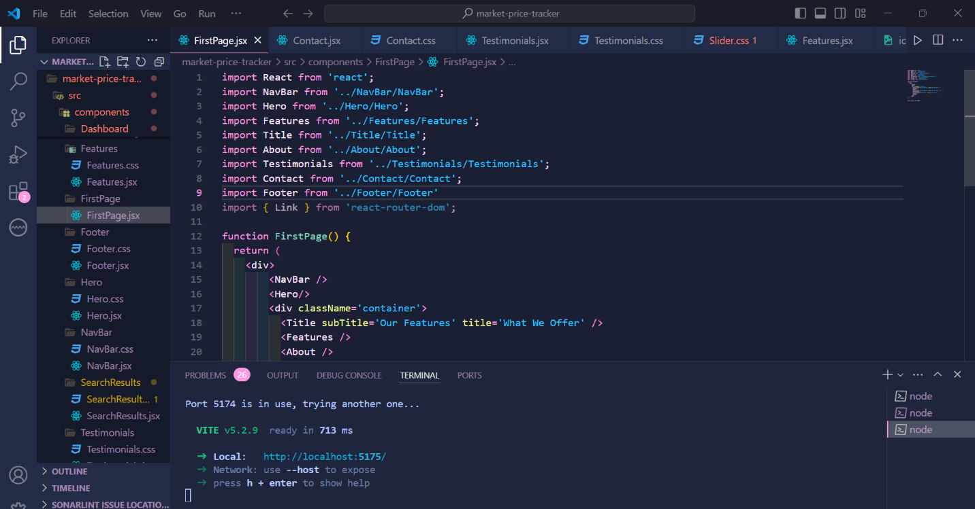

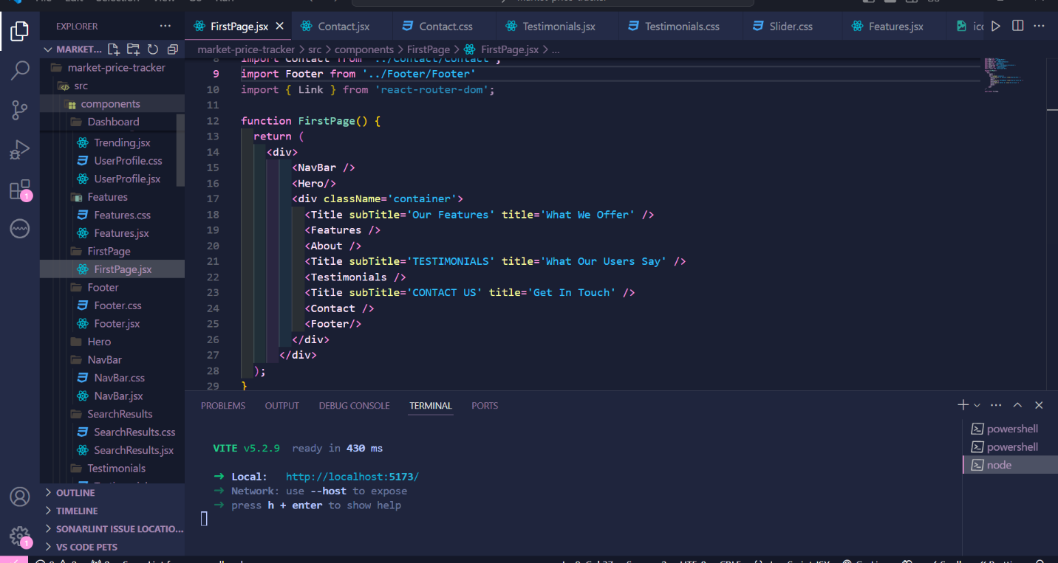

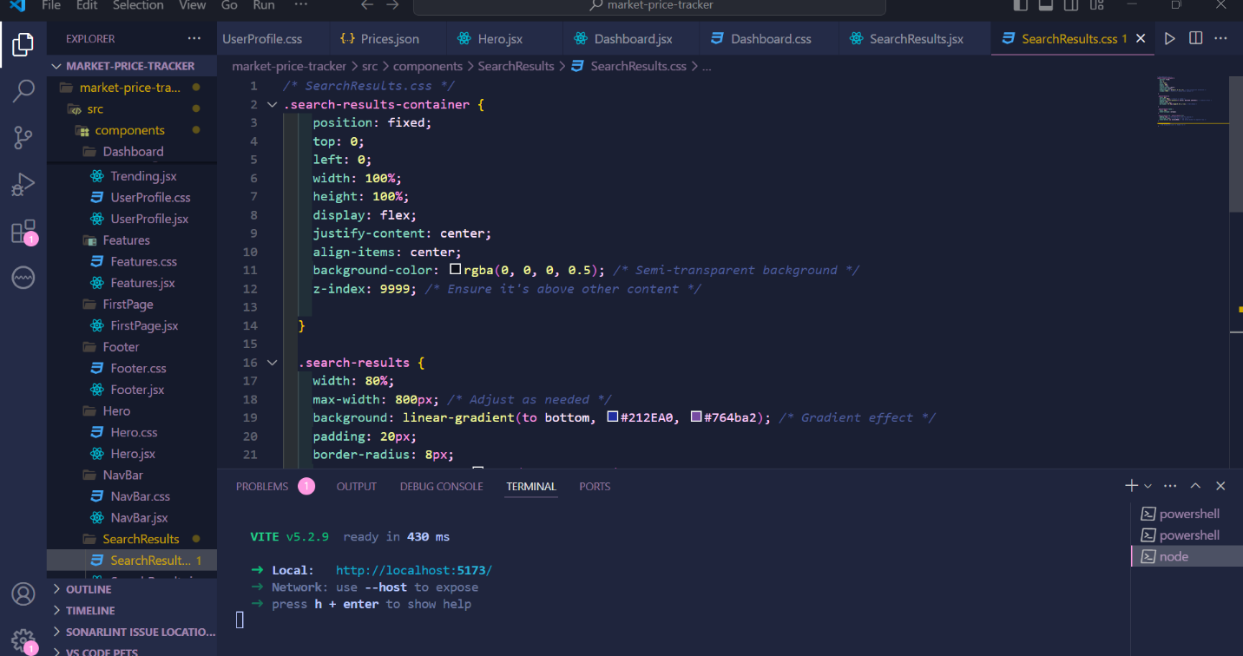



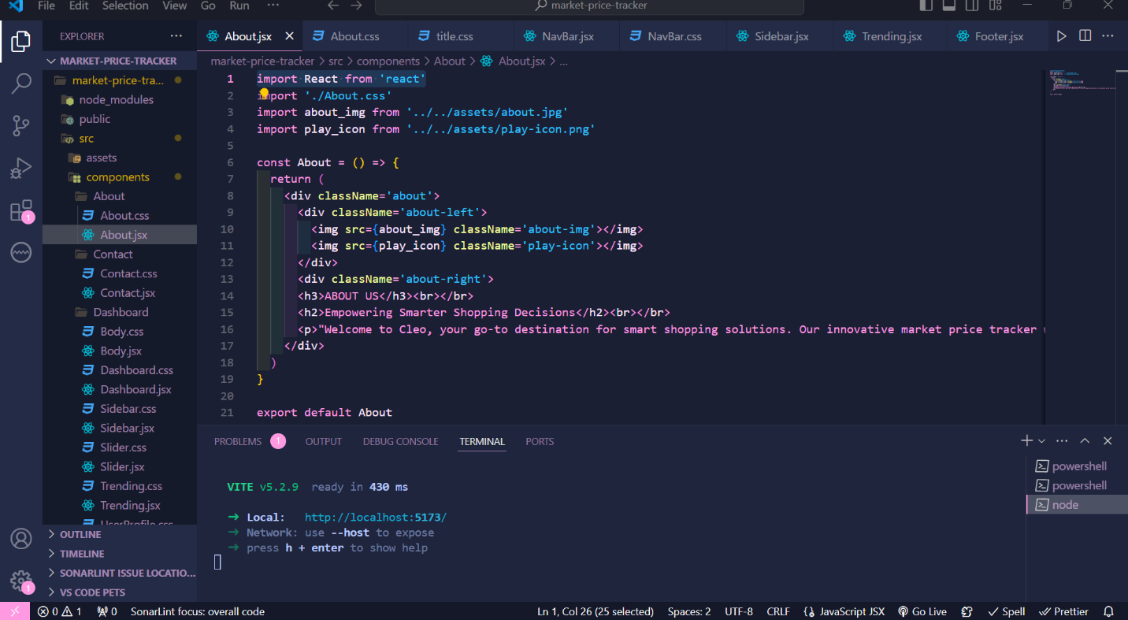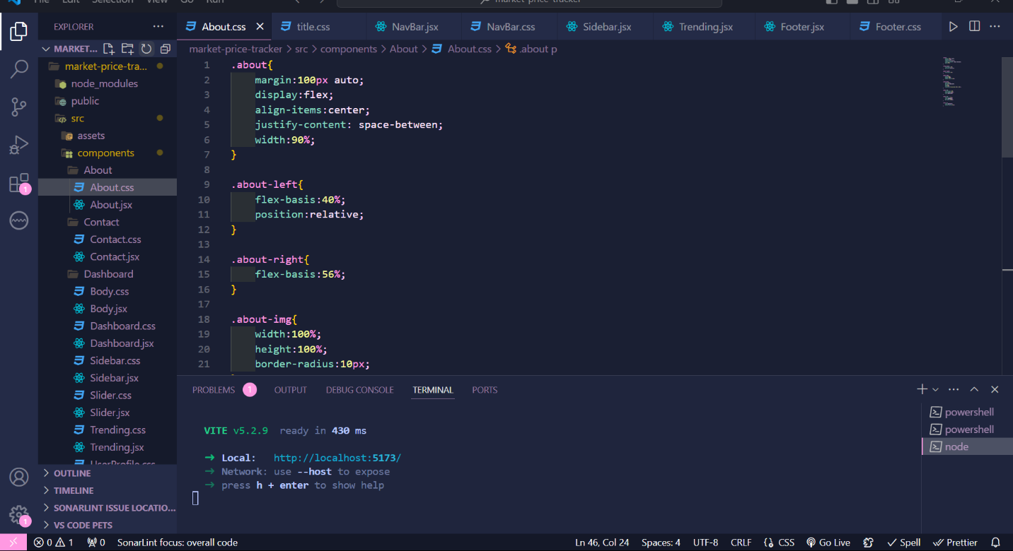

**RESULTS OF PROJECT:-**

**Home Page:**

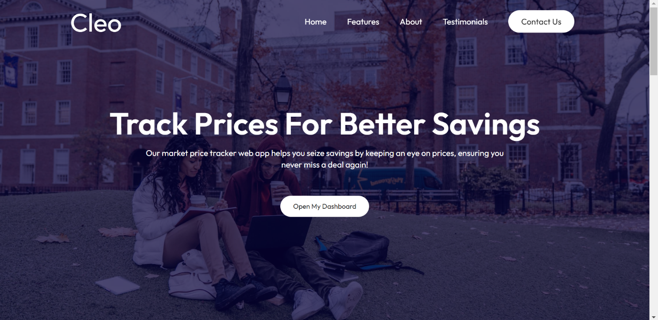







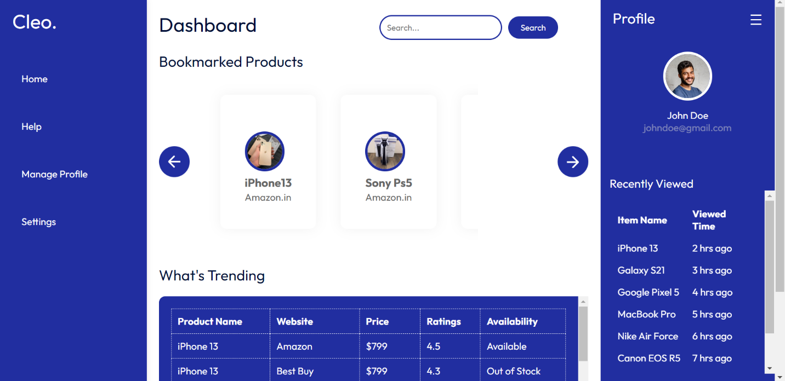

**CONCLUSION:-**

For businesses and consumers alike, navigating the ever-changing world of material costs has often resembled a white-knuckled ride on a rickety rollercoaster. Unpredictable price fluctuations leave budgets in tatters, project deadlines teetering, and home improvement dreams shrouded in uncertainty. Traditional methods of tracking material costs, relying on outdated information or gut instinct, leave everyone vulnerable to sudden market shifts.

The Material Price Tracker seeks to dismantle this chaotic landscape. Built with the power of React, it's your revolutionary solution for regaining control and making informed decisions. Imagine a world where:

* **Businesses** can access real-time data on a vast range of materials, empowering strategic sourcing with accurate and up-to-date market insights. They can analyze historical trends to anticipate potential fluctuations and leverage predictive analytics to forecast future price movements, ensuring well-planned projects and optimized budgets.
* **Consumers** can finally gain transparency into price trends. This allows them to make informed purchasing decisions for home improvement ventures or everyday shopping, eliminating the guesswork and frustration of navigating the unknown.

The Material Price Tracker goes beyond data presentation. It empowers users to analyze trends, predict future movements, and act decisively. User-friendly interface and intuitive visualizations make it accessible to everyone, eliminating the need for time-consuming manual research. With customizable alerts keeping you informed of critical price changes, you can capitalize on buying opportunities and avoid overspending.

Step off the unpredictable price rollercoaster and embrace the Material Price Tracker. Enter a new era of informed decision-making, cost optimization, and financial stability. Our platform empowers you to navigate the complexities of material pricing with confidence, enabling you to achieve your project goals and maximize value for your money.